August 22, 2019
Dear Student,

Welcome to CO 233 Media and Information Literacy! Media, information and technology surrounds us permeating all aspects of our lives in the 21st century. The ability to engage and navigate media and information systems effectively and develop critical thinking and lifelong learning skills are key features of this course.
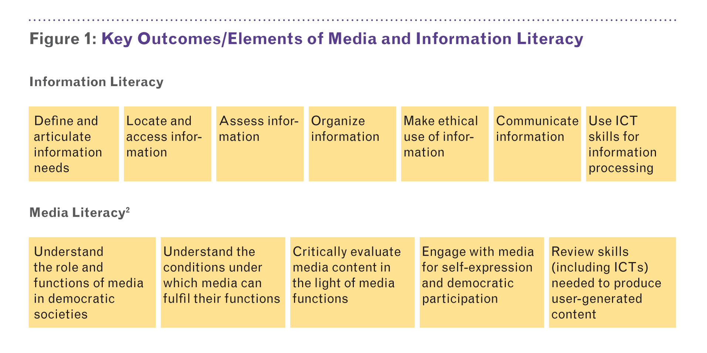
This is a highly interactive, collaborative and tech friendly class – your participation will make this class more engaging for you and your colleagues. Keep in mind that some discomfort is inevitable in classes because the goals of higher education include exposing students to new ideas; having students question beliefs they have taken for granted and grapple with ethical problems they have never considered; and, more generally, expanding their horizons so as to become informed and responsible individuals. You may become frustrated from time to time as you struggle with viewpoints that differ from your own. Although you are welcome to disagree with me and/or your classmates, everyone is expected to participate respectfully. Students who engage in personal attacks; who use rude, insulting, or disrespectful language; or who engage in other disruptive or threatening behavior may face disciplinary action.

What can you expect from me? I will treat you with dignity and respect, especially in cases where a difference of opinion arises. Communication can be tricky though, particularly as I have mannerisms and humor from another part of the world, so sometimes signals get crossed. Please do not hesitate to talk to me about any issues that arise. I will do my best to grade all assignments in a timely manner (within 7-10 days) and will respond to emails within 2-3 days. I will also regularly update the portal so you can see how you are doing in class. My goal is to help you learn the content of the course as well as develop the academic skills of critical thinking, critical writing and reading, and critical digital literacy. In order to do this, I will challenge you to dig deep and we won’t always agree and that’s ok.

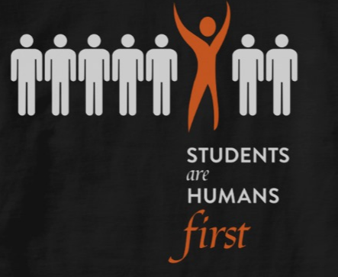
You should know that I am committed to your success (however differently we may conceptualize success). I value cooperative and collaborative learning, knowing that you all have much to contribute. I also value your best effort but recognize that no one can bring their best effort to every assignment, everyday. You can expect me to bring my best effort also. This means I will be prepared to facilitate your learning, listen to you and talk to you (rather than at you). But just like you, it is unlikely that I can bring my best to every single class period (though I shall try my best).

My office hours are designed with you in mind. Please do not hesitate to drop by Mahan 104 (science bldg.) on Mondays between 10-noon or Wednesdays between 11-2pm to chat about class, or anything else I can help you with. If these times don’t work for you, we can figure out a time that does. Email is the best way to get in touch with me natasha.casey@blackburn.edu and your Blackburn email is how I will communicate with you. You can also call me 217-854-5710 or find me on social media: Facebook / Twitter (NatashaCaseyIRL) / LinkedIn

There is no required textbook for this course but we will use Google Drive pretty extensively. You will find links to readings, CPA’s (course preparation assignments) and other helpful resources there. You will need a laptop or other device with internet access to accomplish many in-class assignments. Please arrange to borrow a laptop (you will need your student id) from the Lumpkin Learning Commons before coming to class.

Lastly, you have three homework late passes and can miss two class periods without it negatively impacting your final grade – please use these as you need to (but not all in the first week!)

Looking forward to a great semester,
Dr. Natasha Casey
p.s. call me Natasha or if you are not comfortable with this, Professor Casey or Dr. Casey and use she/her when speaking about me

Student Support Services: We learn as whole people. To learn effectively you must have basic security: a roof over your head, a safe place to sleep, enough food to eat. If you’re having trouble with any of those things, please talk with me or with the Assistant Dean of Students Alondra Olvera (alondra.olvera@blackburn.edu / DCC 134. Together we can work to make sure those needs are met. Students can also anonymously request toiletries/hygiene items and basic food (ramen, granola bars, soups, popcorn, fruit snacks) via the Basics Bins Program at Blackburn via https://blackburncollege.formstack.com/forms/basic_bins_item_request (link can also be found on the portal under this course’s hyperlinks). A package will be placed in your mailbox with the requested items.

The purpose of Counseling Services “is to create a healthy, supportive, safe and welcoming environment for students, faculty and staff. All services are confidential, compassionate and inclusive in order to sustain health and well-being. We believe that everyone, no matter whom, deserves an advocate. Talking to a professional does not mean that you are crazy, broken, defective or weak. It just means that you have taken an action to help yourself with a specific issue happening in your life. It takes courage to do that”. Counseling Services include individualized counseling, crisis intervention, mindfulness based stress reduction and more. Contact either Counselor Tim Morenz (tim.morenz@blackburn.edu / DCC 133) and/or Master's and Graduate level professional staff (hours are available by appointment and often on the same day).

If you are a student with a documented temporary or ongoing disability in need of disability accommodations, please contact the Office of Counseling Services. Students who have made a request for an accommodation that has been reviewed and approved by the Disability Accommodations Coordinator will receive an official accommodation letter, which should be delivered to the instructor or supervisor, as soon as possible. Disabilities may include, but are not limited to: Medical, Psychological, Learning, Mobility, Sensory (including Autism), etc. Accommodations are based upon underlying medical and/or cognitive conditions and could include an Academic or Workplace adjustment. For confidential assistance please contact Tim Morenz at tim.morenz@blackburn.edu or stop by DCC 133.

Regardless of whether or not you have a documented disability, please come talk to me about ways we can make this class work for you, especially if you struggle with anything in the class (like generating ideas, writing, reading, concentration, time-management,
and/or anxiety over succeeding).

The Lumpkin Learning Commons provides a variety of academic support services, such as tutoring and includes Blackburn’s campus writing center The Writer’s Block which assists students in identifying and addressing personal writing challenges at any stage in the writing process - from brainstorming, composing, organizing, revising and proofreading - through respectful and challenging peer discussion. Students enrolled in any course are welcome to drop by. Also located in Lumpkin is Learning Center Coordinator Barbara Clark (barbara.clark@blackburn.edu) - both she and Academic Resource Assistants are available to provide academic support.
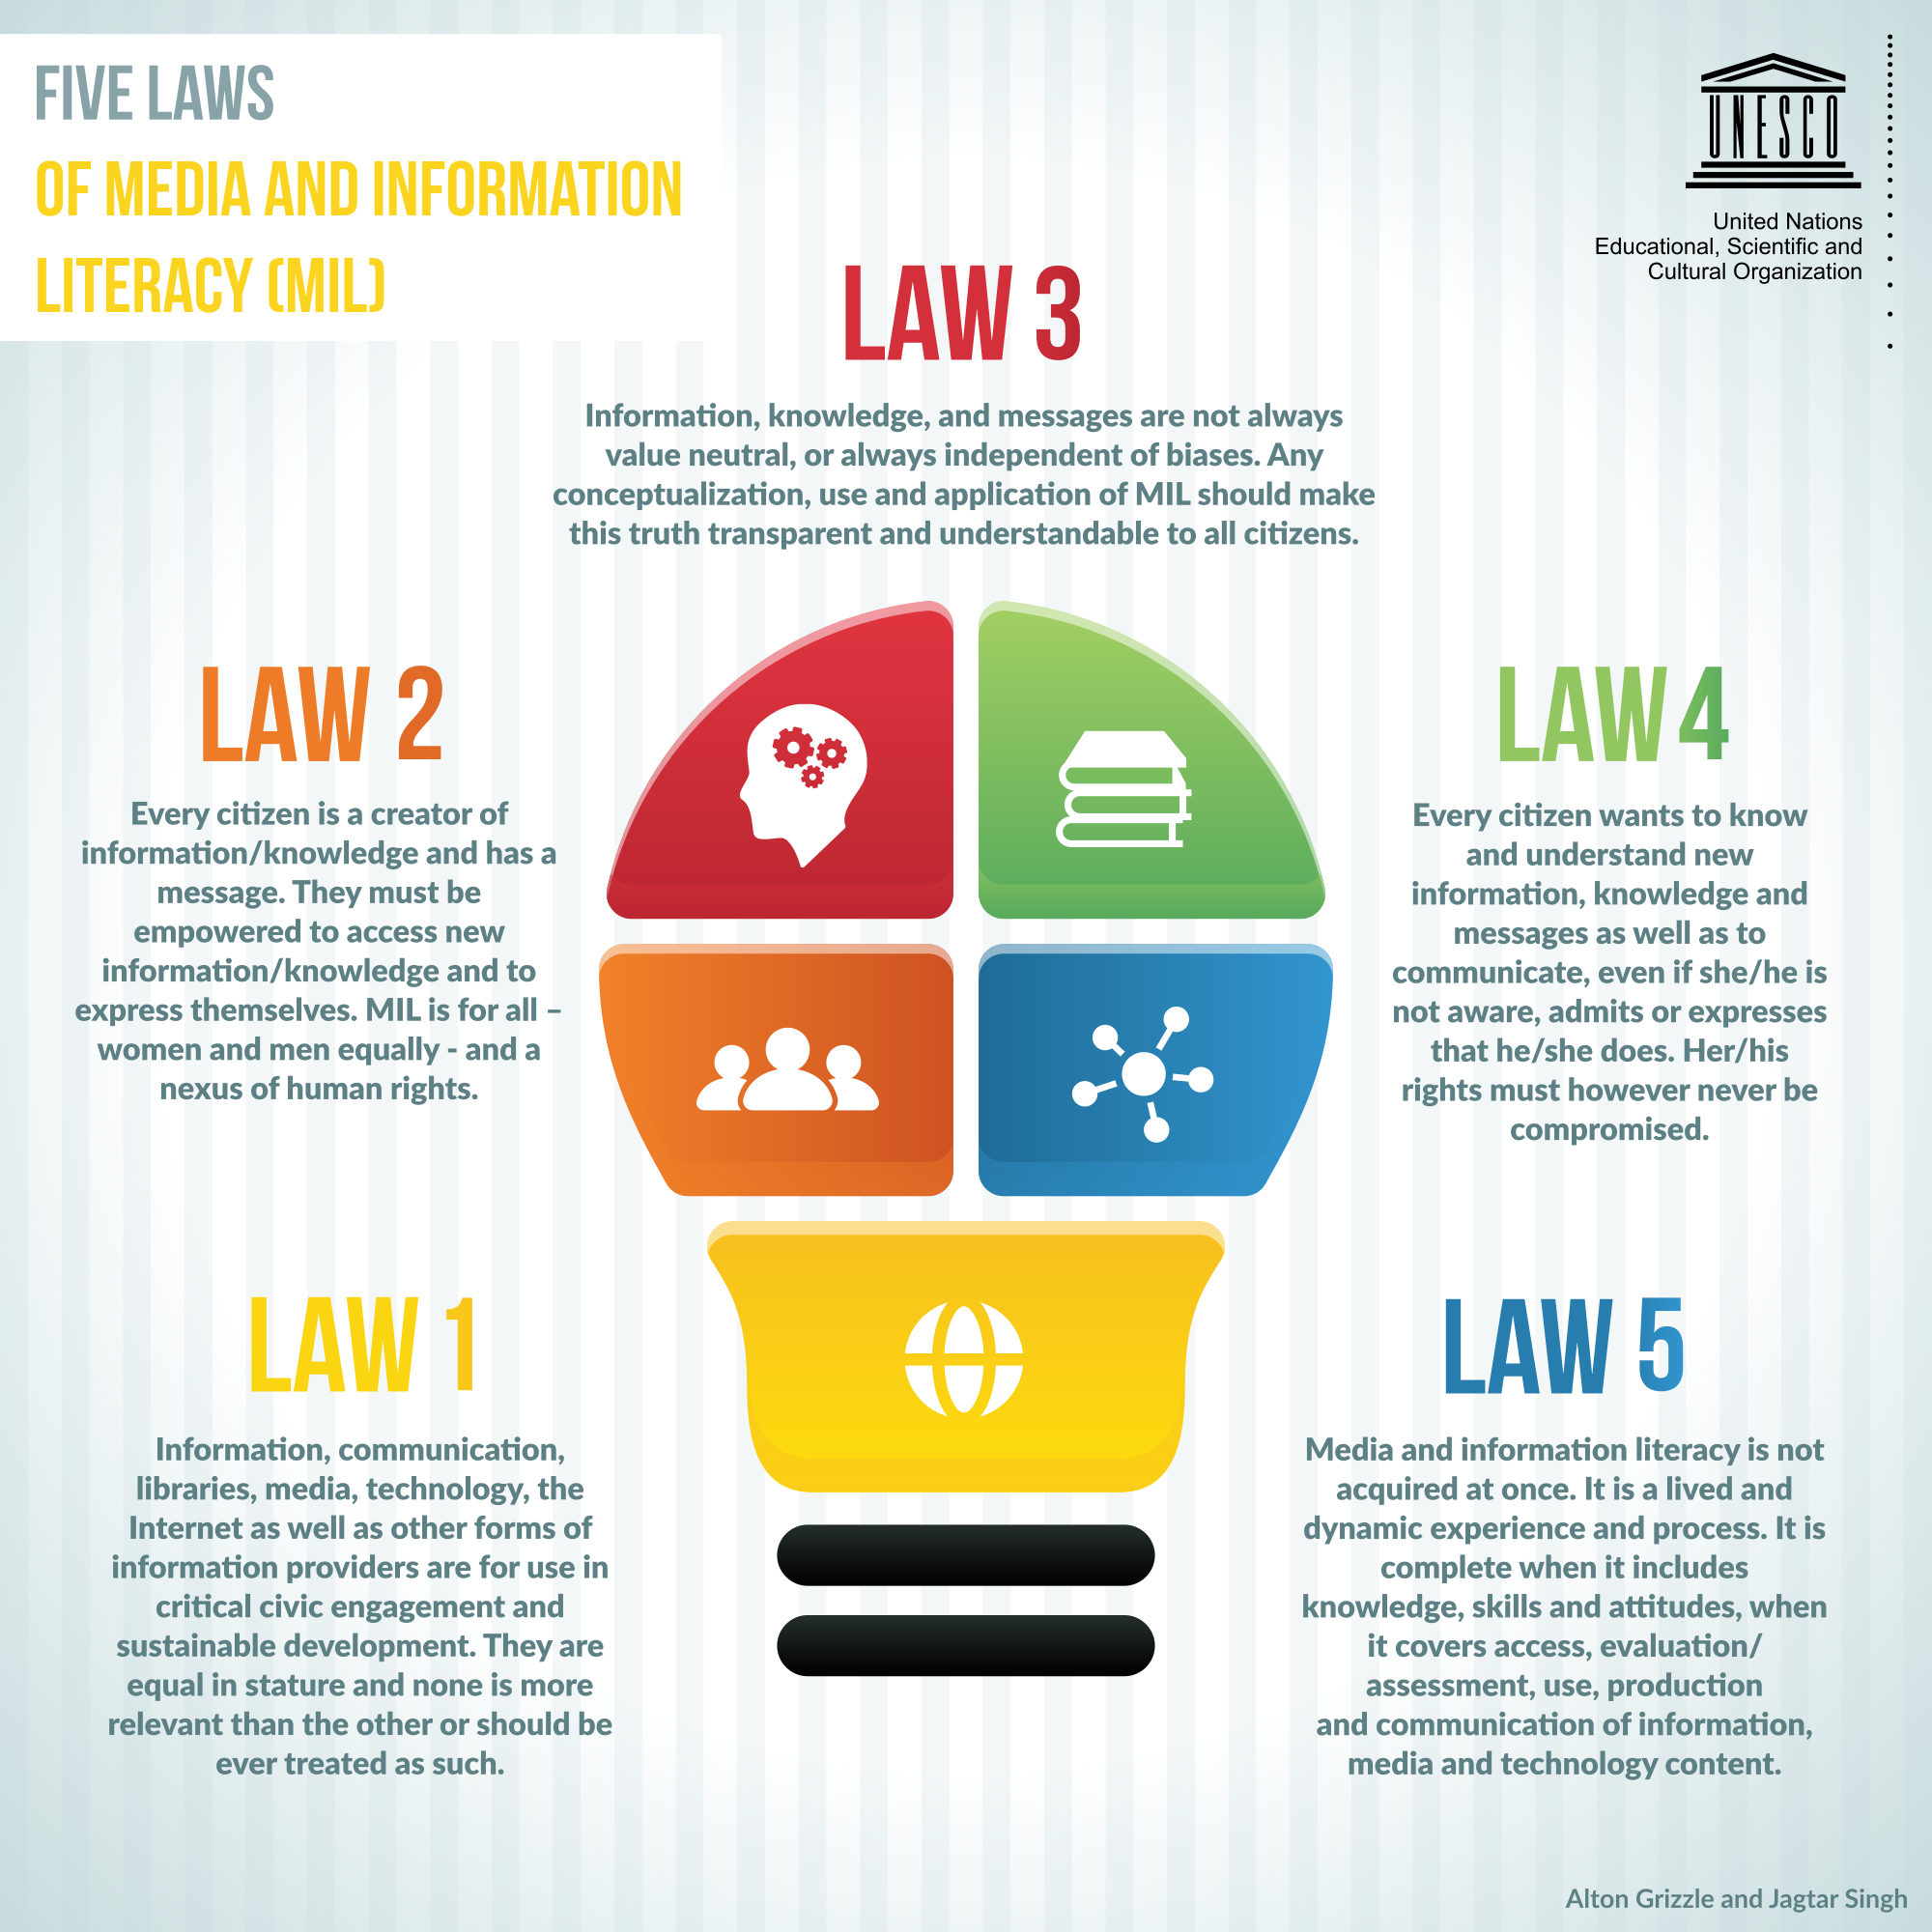
Course Objectives: When you successfully pass this course, you will be able to do the following:

- Recognize the construction of media and information messages as a social process, rather than accepting texts as neutral or transparent conveyors of information.

- Analyze languages, genres, codes, and conventions of various mediums of communication (digital, visual, print-based, etc.).

- Explore the roles audiences play in actively negotiating meanings and how audiences contribute to positioning themselves in the meaning-making process.

- Examine the process of representation to uncover and engage issues of bias, point of view, ideology, omission, aesthetics, power, privilege, and pleasure in the content of the text and the influence of the medium.

- Study the institutions and systems that motivate and structure media and information locally and globally.

- Question media and information about issues of representation because they have impact and influence, yet many effects are long-range and difficult to prove. Since media and information do not operate in isolation from the world around them, some people and groups benefit more than others from media and information messages.

Assignments:
1. Syllabus, Mini-Lectures & Notes. A copy of the syllabus is posted on Google Drive in case you misplace this hard copy. Mini-lectures will be used to expand on issues raised within course readings, videos, etc. Everyday, 2 or 3 people will collaboratively take notes on Google Drive – these will be invaluable for your reflection paper/production and team project.

2. Course Preparation Assignments (CPA’s): Rather than give a weekly quiz over the assigned readings, videos etc. (which typically none of us enjoy), there are weekly course preparation assignments. They are graded pass-fail. There are three requirements for these assignments:
- You must make a good faith effort (they should be typed in 12 point font)
- You must bring a hard copy of each assignment to class
- Attend class to expand on your answers and add value to class discussion
If you do not show good faith effort on all the questions, or do not bring a hard copy of your answers, or add attend class and add value to the discussion, then you will not earn credit for that course preparation assignment.

3. Weekly Twitter Assignment: Read the article ‘Twitter Tips’ in Google Drive and set up a Twitter account (add your Twitter handle to the document on Google Drive). By the end of the first full week of class, you should be following everyone in the class, and at least 10 media/information literacy advocacy groups/organizations/ individuals. After class every Thursday (you have up to 48 hours to complete this task) you must:
- Tweet your takeaway from the week (something you learned, were surprised by, disagreed with, etc.) or ask a question you would like addressed in the next class. Use the class hashtag #CO233BC. Sometimes this will take the form of a gif or a meme (refer to schedule below)
- Use the class hashtag and interact with at least one other person in the class (don’t pick the same person every week!)
- Follow at least one new media/information literacy advocacy group/organization/individual – be prepared to discuss why you made this choice!
- At the end of the semester you will submit a doc with screen captures of your tweets. If you’ve never used Twitter before, check out these out helpful sites: https://bit.ly/2MDj9rW / https://bit.ly/2MD7ppn / https://bit.ly/2MD7RUB

4. 24 Hours Without Electronic Media Assignment: See guidelines on Drive.

5. Course Reflection Paper OR Course Reflection Media Production: See guidelines on Drive.

6. Team Project: You are required to make a presentation OR media production with another member of the class on a media and information literacy topic. A list of topics will be distributed in class. Additional guidelines will also be discussed in class and posted on the Drive.

7. Class Participation: Using the Drive to take notes (and sharing them with your colleagues) counts towards your participation grade. You will also have the opportunity to raise questions and/or make comments on what we have discussed and learned. Note that participation is defined not by speaking or commenting for the sake of it, rather by raising questions and promoting discussion among your peers in a respectful manner. In order to participate in the exchange of ideas and opinions, please ensure that you are prepared for class.
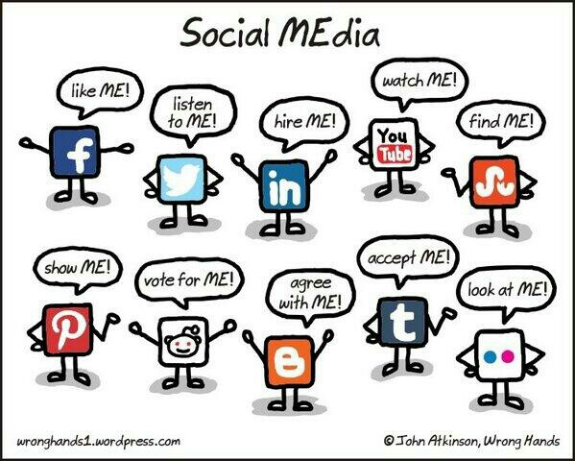
Grading:
- 24 Hour No Media = 15%
- Twitter = 14%
- Reflection Project = 20%
- Team project = 22%
- Participation = 5%
- CPA’s = 24% (2% each)

*There may be opportunities for a small amount of extra credit if an enterprising student suggests something fabulously creative and relevant.

Grading Scale:
A = 93-100 A- = 90-92 B+ = 87-89 B = 83-86 B- = 80-82 C+ = 77-79
C = 73-76 C- = 70-72 D+ = 67-69 D = 63-66 D- = 60-62 F = Below 60

Late Passes
- Life is complicated and college is not always the most important thing happening in it. To accommodate this, you have 3 late passes (late passes are granted per assignment, not per day or week). To use a late pass, you must:

- Notify Natasha before the assignment is due (anytime up to 10am on the day of class). The notification must be via email and use “late pass” in the subject line (see below). You do not have to say why you are asking for the late pass. Your request will be approved as long as you have a late pass remaining.
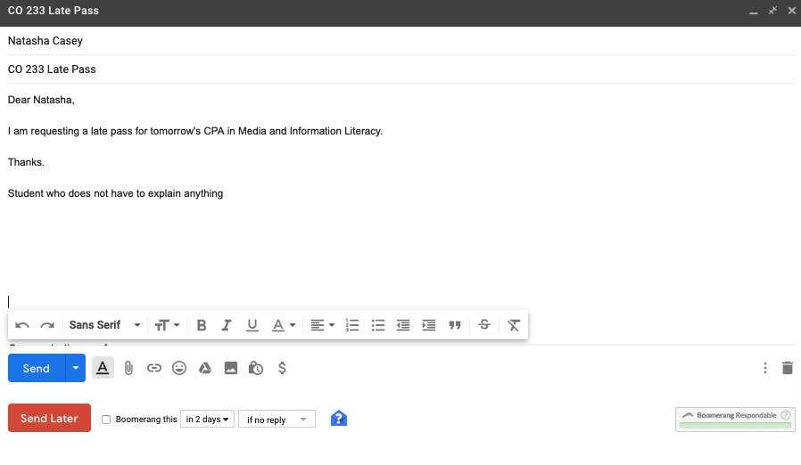
- Turn in the assignment within 4 days of the due date with a note that it is being submitted late with a late pass.

- After you have used your late passes or if you have neglected to request one, late work will not be accepted. Because of the short period of time between the end of the semester and when grades are due, a late pass cannot be used on team project or any assignment due in DIPS.
Attendance: You are permitted two absences (one week!) over the course of the semester (choose these wisely – flu/cold and the need for a personal day is inevitable!). Each absence beyond this will automatically lower your final grade one half of a letter. Please be on time.

*Please Note! If you miss class for a college-sanctioned event (i.e. field trip, athletics, etc.), you must turn in (not via email) any assignments due that day early.

Academic Honesty: All projects and assignments must be original and made exclusively for this class. Plagiarism is borrowing another’s words/ideas and passing them off as your own by failing to use quotation marks, adequate paraphrasing, or proper citation, or having someone else write your paper for you. If evidence of plagiarism is found, you will receive a zero on the assignment, possibly an F in the course, and it will be formally reported to the Provost. If you are unsure about what constitutes plagiarism, please talk to me. Blackburn’s detailed plagiarism policy can be found in your “B Book”.

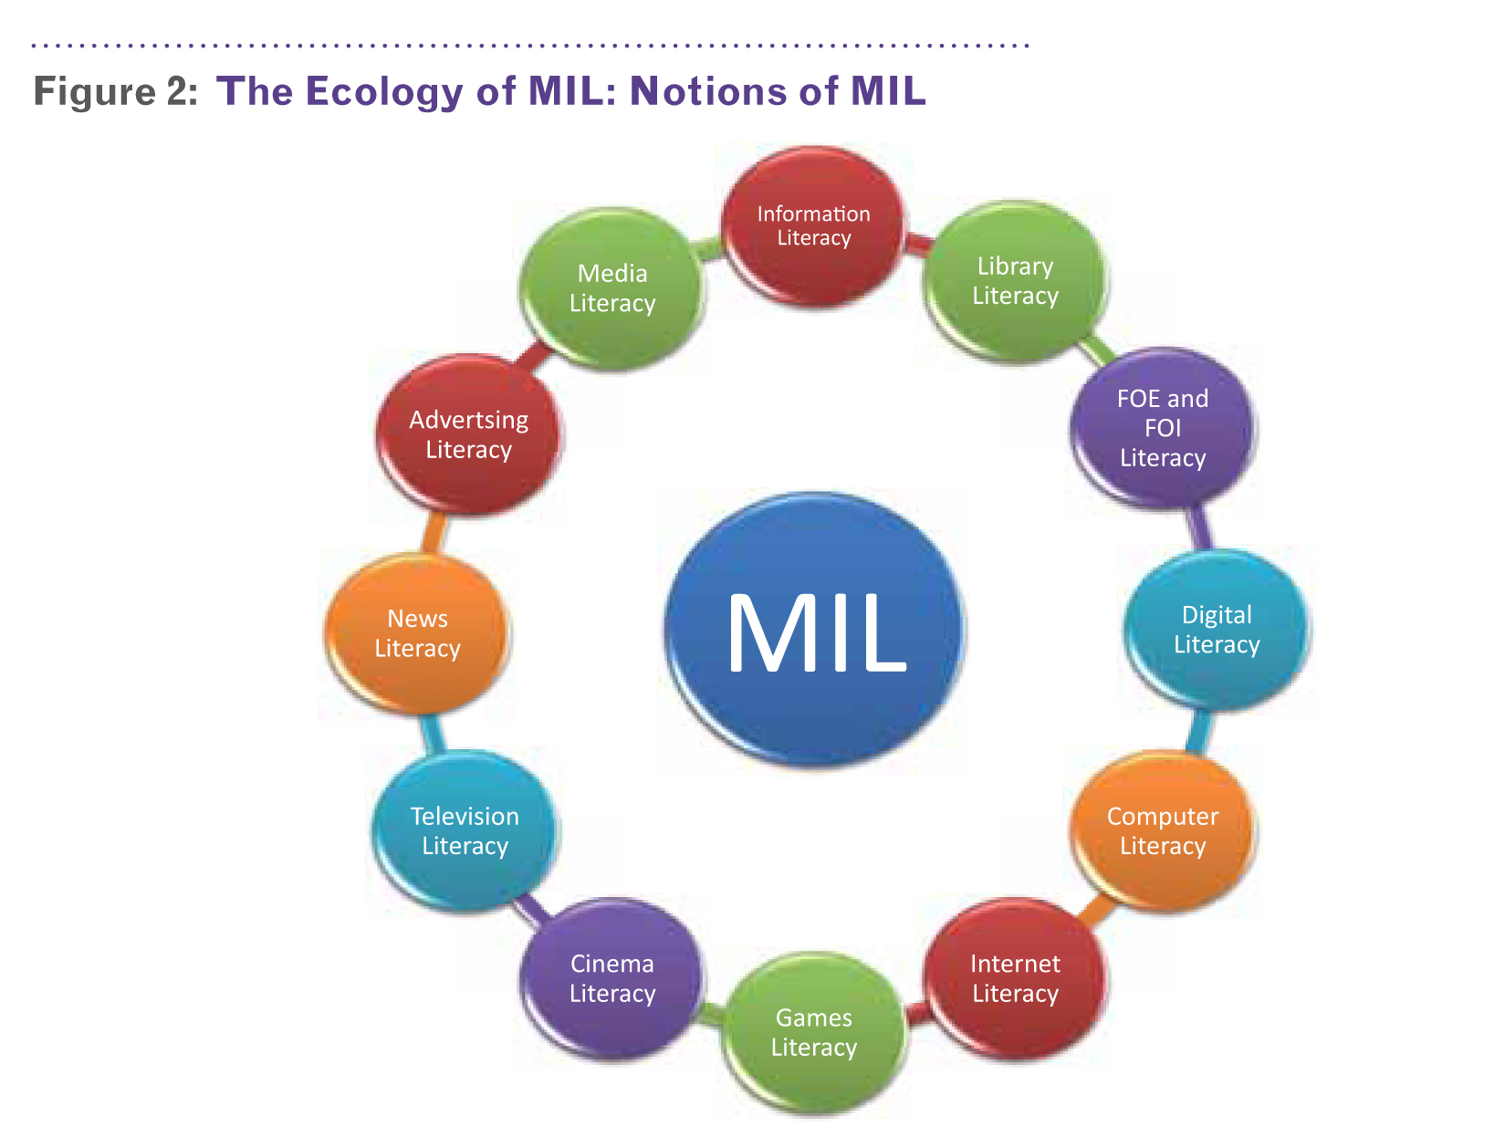

Blackburn College / Fall 2019
3 credit hours / 40 contact hours
Tuesday & Thursday 2.00-3.20pm
Lumpkin Learning Commons, Room 120

Schedule
Date | Topics / Readings | Assignments Due
Thurs Aug 22  Week 1 | Class Intro / Quiz Qs / Twitter (& point of) / Google Notes | None
Tues Aug 27  Week 2 | Twitter / This is Media / Google Notes | Read Why you procrastinate  Read Laziness does not exist but unseen barriers do  Read A Swiss army knife for your mind  Write two paragraphs about each article detailing your main takeaways
Thurs Aug 29  Week 2 | What is Media & Information Literacy? / Google Notes | Read Media & Information Literacy: An Introduction by UNESCO  Read Media & Information Literacy: Evaluating & Using Info & Media Content by UNESCO  Read What does information literacy even mean these days?  CPA Due & Tweet your takeaway
Tues Sept 3  Week 3 | Key Concepts & Principles of Media & Information Literacy / How do you know what you know online?/ Google Notes | Read Five Key Concepts for Analyzing Media Messages Online and Offline  Read At Sea in a Deluge of Data  Watch Crash Course in Media Literacy  CPA Due
Thurs Sept 5  Week 3 | Key Concepts & Principles of Media & Information Literacy  MEF Handout / How to make a meme / Google Notes | Bring an advertisement to class (something you might see in a magazine or a billboard)  Tweet your takeaway in meme form
Tues Sept 10  Week 4 | Analyzing Media / Media Codes / MEF Handout / How to make a gif / Google Notes | Read How to Teach Media Language  Watch The Key to Media’s Hidden Codes  CPA Due
Thurs Sept 12  Week 4 | Advertising & Propaganda / Influence & Persuasion / Native Advertising / Introduce Screencast Project /Google Notes | Tweet your takeaway in gif form
Tues Sept 17  Week 5 | Work on Screencast Project | Read/Watch Various Screencast Tutorials  Work on Screencast
Thurs Sept 19  Week 5 | Screencast Project | Email Screencasts to Natasha before class!  Tweet your takeaway
Tues Sept 24  Week 6 | Representation / Real World vs Mediated World / Photo Manipulation/Image search / How Verify Images/Google Notes | Watch: Representation: An Introduction  Read: Representation (first 5 pages only!)  Watch: The evolution of black representation in film  CPA Due
Thurs Sept 26  Week 6 | Character Day / Orbiting / Online & Offline Identities / Your Digital Footprint / Google Notes | Tweet your takeaway in meme form
Tues Oct 1  Week 7 | How Google Works / Algorithms /Privacy, Surveillance, Data Mining / Terms & Conditions / Google Notes | Read What tech giants do with your data?  Read Google tracks movements, like it or not  Read Data is a fingerprint  CPA Due
Thurs Oct 3  Week 7 | Filter Bubbles / Data Driven Discrimination / How Facebook Figures Out Everyone You’ve Ever Met / Google Notes | Tweet your takeaway in gif form
Tues Oct 8  Week 8 | Participatory Culture & Civic Engagement / Discuss 24 Hours Without Media Assignment / Google Notes | Read Online communities are the best thing about the internet  Read Harry Potter as a political force  Read Confronting the challenges  Watch Henry Jenkins  CPA Due
Thurs Oct 10  Week 8 | Media (even Social Media) for Good? / Google Notes / Introduce Team Project | Read How Video Games Can Heal  Read YouTube Show restored faith humanity  Read Promoting empathy social justice online  Watch Unlocking viral video for social good  CPA Due  Tweet your takeaway
Fri Oct 11 | Fall midterm break begins 5pm
Wed Oct 16 | Course instruction resumes 8am
Thurs Oct 17  Week 9 | Natasha in STL with CO 131 - no class  Media & Information Economics | Watch Media & Money  Watch Media Ownership  Tweet your takeaway in meme form
Tues Oct 22  Week 10 | National Media Literacy Week / Digital Divide / Team Partners / MIL Economics Follow Up / Google Notes | 24 Hours Without Media Assignment Due
Thurs Oct 24  Week 10 | National Media Literacy Week  Media / Information Technology & Moral Panics / Google Notes | Read Has Smartphone Destroyed a Generation  Read Response Smartphone Dest Generation  Read Don’t Touch Dial: Hist Media Moral Panics  CPA Due  Tweet your takeaway
Tues Oct 29  Week 11 | Open Source Media & Information / Google Notes | Watch Laws that choke creativity  Read Guerilla open access manifesto  Read Open access books . . .  Read Free digital textbooks versus purchased commercial textbooks  CPA Due
Thurs Oct 31  Week 11 | Remix Culture / Remix everything / Embrace the remix / RIP! A Remix Manifesto / Google Notes | Tweet your takeaway
Tues Nov 5  Week 12 | Do We Have to Talk about Fake News? / Fiskkit | Read Rogow Fake News (on Google Drive)  CPA Due & Fiskkit log in
Thurs Nov 7  Week 12 | Work on Team Project | Tweet your takeaway in gif form
Tues Nov 12  Week 13 | Natasha at conference – no class | Work on Team Project
Thurs Nov 14  Week 13 | Natasha at conference – no class | Work on Team Project  Tweet your takeaway
Tues Nov 19  Week 14 | Participatory Culture & Civic Engagement / Google Notes  Discuss Final Paper (use Tweets!) | Read Should university students use WP?  Read Wikipedia: strengths and weaknesses  Read The Top 10 reasons cannot cite Wikipedia  CPA Due
Thurs Nov 21  Week 14 | Wikipedia Project / Google Notes | Create Wikipedia Account  Find an entry you have some expertise in  Read Blackburn College entry  Tweet your takeaway
Tues Nov 26  Week 15 | Work on Final Paper
Thurs Nov 28  Week 15 | Thanksgiving – no class
Tues Dec 3  Week 16 | Work Team Projects/Final Paper
Thurs Dec 5  Week 16 | Work Team Projects/Final Paper | Final Paper Due  Tweet your takeaway
Tues Dec 10 | Study Day – No Class
DIPS (tba) | Team Projects | Team Projects Due / Final Twitter Due
*Please note that if necessary this syllabus is subject to change

This course was developed by Natasha Casey & Spencer Brayton
Adapted with permission from http://www4.uwm.edu/schedule/syllabi/215249872.pdf and http://www.unesco.org/new/fileadmin/MULTIMEDIA/HQ/CI/CI/pdf/media_and_information_literacy_curriculum_for_teachers_en.pdf
This assignment was modified in part after Dr. Belinha De Abreu shared her Twitter assignment with me.

